Use-case-8

Technical Stack:

1. Custom VPC
2. Subnets ( Public Subnets in 2 AZs for ALB and NAT gateways and private subnets in 2 AZs for ECS services)
3. Internet Gateway
4. NAT gateways: Enable outbound internet access for private subnets
5. Route tables: configured for proper traffic routing
6. ECS Fargate Cluster: serverless container platform
7. ECS Services: Patient service (manages patient data) and Appointment service (manages appointments)
8. Task Definitions: Define container specifications and resource requirements
9. Application Load Balancer: Routes traffic based on the path patterns

/api/patients\* - Patient service

/api/appointments\* - Appointment serice

1. Target Groups : Health checks and service registration
2. ECR Repositories: Store Docker images
   1. healthcare-app-{env}-patient-service
   2. healthcare-app-{env}-appointment-service
3. Lifecycle Policies: Retain last 5 tagged images
4. IAM Roles:
   1. ECS Task Execution Role: Pull images and write logs
   2. ECS Task Role: Application-specific permissions
5. Security Groups:
   1. ALB Security Group: Allow HTTP/HTTPS from internet
   2. ECS Security Group: Allow traffic from ALB only
6. CloudWatch Log Groups: Application and container logs
7. CloudWatch Dashboards: Service metrics visualization
8. CloudWatch Alarms: CPU utilization monitoring
9. Container Insights: ECS cluster monitoring

Architecture Diagram:

Internet Gateway

|

Application Load Balancer

|

ECS Fargate Services

/ \

Patient Service Appointment Service

| |

Private Subnets (Multi-AZ)

|

NAT Gateways

|

Internet Gateway

appointments-service:

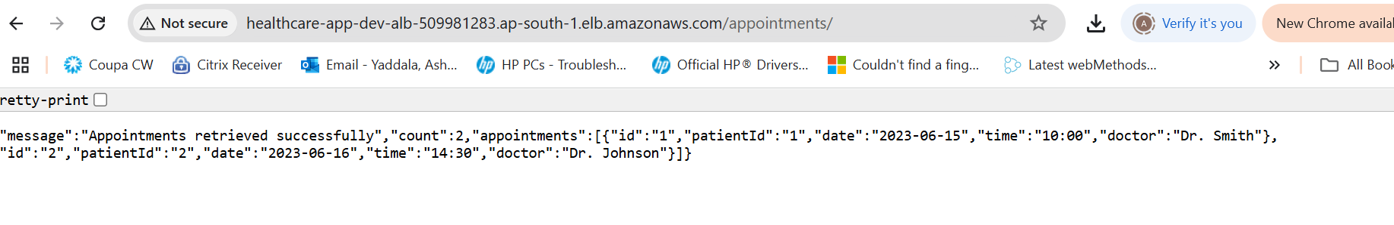

Patient-service:

